UNIVERSITY OF IBADAN
DISTANCE LEARNING CENTRE (DLC)
DEPARTMENT OF COMPUTER SCIENCE

Machine Learning Model for Predicting House Rent Prices in Ibadan: A data driven approach for Real Estate Valuation

BY

ROTIMI ISRAEL TAYE
MATRIC NO: E047849

Supervised by

MR. O. A. Abiola

A PROJECT SUBMITTED TO THE DEPARTMENT OF COMPUTER
SCIENCE, UNIVERSITY OF IBADAN, IBADAN, NIGERIA

IN PARTIAL FULFILLMENT OF THE REQUIREMENT FOR THE
AWARD OF BACHELOR OF SCIENCE (B.Sc.) IN COMPUTER
SCIENCE.

Abstract
House rent estimation remains a significant challenge due to inconsistent pricing methods, reliance on manual valuation, and the absence of intelligent systems for determining fair rent values. Traditional approaches used by house agents and property owners often result in price variations and inaccurate rent estimations, particularly in rapidly urbanising cities like Ibadan, Nigeria.
This study developed a House Rent Prediction System using Linear Regression to estimate annual house rent values based on housing characteristics. The dataset — comprising 10,000 records across 11 features — was obtained from house agents and secondary sources and was preprocessed through data cleaning, One-Hot Encoding, and feature scaling using StandardScaler. The model utilised features such as location, property type, bedrooms, bathrooms, house size, lot size, furnishing status, water supply, PHCN availability, and year built.
The developed system was implemented using Streamlit and included modules for manual prediction, property visualisation, house comparison, prediction history, market analytics, and dark mode. Model evaluation using MAE, MSE, RMSE, R² Score, and 5-Fold Cross-Validation demonstrated strong predictive performance, with an R² score of 0.928 and an average cross-validation score of 92.49%.
Keywords: House Rent Prediction, Linear Regression, Machine Learning, Streamlit, Housing Valuation, Ibadan, Nigeria.

Chapter One: Introduction

1.1 Background of the Study
Housing is a fundamental necessity that provides individuals with shelter and security. However, the housing market — particularly in developing urban environments — is often plagued by inflated rent prices and a lack of transparency. House agents frequently set rents without reference to market data, creating a gap between actual property value and the amounts tenants are required to pay.
The real estate sector is one of the most economically significant industries in many countries, with housing prices influenced by a wide range of factors including location, property size, structural features, and prevailing market conditions. Traditional property valuation — which relies on manual appraisal and comparative analysis — is often time-consuming, inconsistent, and susceptible to human error, especially when applied to large datasets.
With the rapid growth of digital real estate platforms and the increased availability of large-scale property data, there is growing demand for automated, data-driven valuation methods. Machine learning techniques, particularly Linear Regression, offer interpretable, effective solutions for modelling the relationship between property characteristics and rental prices.

1.2 Problem Statement
Accurately determining residential rental prices is a major challenge in the Nigerian real estate industry. Traditional valuation methods rely heavily on subjective human judgment and basic comparison techniques, which are inconsistent and inefficient — especially when applied to complex, large datasets. Real estate datasets also typically contain missing values, inconsistent formats, and features measured at different scales, all of which negatively affect the quality of predictive models.
There is therefore a clear need for a reliable, data-driven system that can automatically analyse property features and produce accurate rent estimates while incorporating proper preprocessing and rigorous evaluation techniques.

1.3 Aim and Objectives
The aim of this study is to develop an accurate, data-driven predictive model for rental housing prices in Ibadan using Linear Regression, supported by thorough data preprocessing and validated through k-fold cross-validation. The specific objectives are:
- To collect and preprocess housing data through cleaning, transformation, One-Hot Encoding, and feature scaling.
- To develop a machine learning model for predicting house rent using relevant housing features.
- To evaluate the performance of the developed model using MAE, MSE, RMSE, R² Score, and K-Fold Cross-Validation.

1.4 Significance of the Study
This study demonstrates how machine learning can be applied to real estate valuation in a developing urban context. By developing a predictive model, it provides valuable guidance for buyers, tenants, landlords, and investors seeking data-driven decision-making. It also highlights best practices in data preprocessing and model evaluation, and serves as an educational resource for students and practitioners learning practical machine learning workflows.

1.5 Scope and Limitations
The study is limited to the variables available in the collected dataset and employs only Linear Regression as the predictive technique. Advanced ensemble models such as Random Forest, XGBoost, and Neural Networks are acknowledged but not implemented. The dataset is primarily sourced from Ibadan, which limits the model's generalisability to other geographic regions. Temporal fluctuations in rental prices and broader economic indicators are also not captured.

Chapter Two: Literature Review

2.1 Housing Rent and Real Estate Valuation
Residential properties provide accommodation, security, and investment opportunities. Rent refers to periodic payments made by tenants for the use and occupation of property (Onyejiaka et al., 2025). Rental values vary across locations due to accessibility, infrastructure, neighbourhood quality, and market demand. Traditional valuation relied on manual appraisal, which Balila and Shabri (2024) found to be subjective and inconsistent compared to machine learning approaches.

2.2 Machine Learning and Predictive Analytics in Real Estate
Machine learning is a branch of artificial intelligence enabling systems to learn patterns from data without explicit programming. Geerts, Vanden Broucke, and De Weerdt (2023) observed that machine learning has transformed real estate analytics by enabling automated and scalable property valuation. Key applications include property valuation, rental price prediction, market trend forecasting, and investment risk assessment. Algorithms commonly applied include Linear Regression, Random Forest, XGBoost, Support Vector Regression, and Neural Networks.

2.3 Linear Regression in Housing Price Prediction
Linear Regression is one of the most widely used supervised learning algorithms for predicting continuous values. The equation is: y = β₀ + β₁x₁ + β₂x₂ + ... + βₙxₙ + ε, where y is the predicted rent, β₀ is the intercept, β₁…βₙ are coefficients, x₁…xₙ are feature values, and ε is the error term. Balila and Shabri (2024) confirm that Linear Regression remains an effective baseline algorithm because it produces interpretable results at low computational cost.

2.4 Determinants of House Rent Prices
Key determinants of rental values include location, proximity to educational institutions and transport, neighbourhood quality, number of bedrooms and bathrooms, house and lot size, furnishing status, water supply, and electricity availability (Bamiteko & Adebiyi, 2020; Sharma et al., 2024). In Ibadan specifically, areas surrounding the University — such as Agbowo, Ajibode, and Sango — experience higher rental demand and prices due to student populations (Odebode et al., 2024).

2.5 Data Preprocessing and Model Evaluation
Effective preprocessing is critical to model performance. Key techniques include data cleaning, handling missing values, One-Hot Encoding for categorical variables, and StandardScaler for feature normalisation (Chuhan, 2024). K-Fold Cross-Validation, in which the dataset is divided into k subsets for iterative training and validation, provides a more robust performance estimate than simple train-test splitting and reduces overfitting (Yagmur, Kayakus, & Terzioglu, 2022). Evaluation metrics include MAE, MSE, RMSE, and R².

2.6 Gaps in Existing Literature
Most existing housing price prediction studies focus on developed countries or major metropolitan areas like Lagos. Limited empirical work exists on machine learning-based rent prediction specific to Ibadan. Furthermore, few studies have integrated interactive web deployment (e.g., via Streamlit) with ML prediction, property visualisation, and comparison tools within a single system. This study addresses these gaps.

Chapter Three: Methodology

3.1 Overview of the Proposed System
The proposed House Rent Prediction System is a machine learning-based web application that estimates annual house rental values from user-provided or pre-loaded property characteristics. The system was designed to address the limitations of existing manual rent estimation approaches by providing an automated, data-driven, and interactive solution.

3.2 Dataset and Data Collection
The dataset used for this study comprised 10,000 housing records across 11 features, sourced from house agents in Ibadan and supplemented by secondary data from online platforms and social media. The dataset attributes are:
Feature | Type | Description
Location | Categorical | Area within Ibadan
Property Type | Categorical | Flat, Duplex, Self Contained, etc.
Bedrooms | Numerical | Number of bedrooms
Bathrooms | Numerical | Number of bathrooms
House Size (sqm) | Numerical | Floor area in square metres
Lot Size (sqm) | Numerical | Total land area
Year Built | Numerical | Year of construction
Furnishing | Categorical | Furnished / Semi / Unfurnished
Water Supply | Categorical | Borehole / Public / Well
PHCN Availability | Categorical | Stable / Moderate / Poor
Annual Rent (NGN) | Numerical (Target) | Rent value to predict

3.3 Data Preprocessing
Raw data was prepared for modelling through the following steps:
- Data Cleaning: Removal of duplicate records and handling of missing values. All 11 columns were confirmed to have zero missing values after cleaning (cleaned dataset shape: 10,000 × 11).
- Feature and Target Separation: The target variable (Annual_Rent_NGN) was separated from the feature set.
- One-Hot Encoding: Categorical variables (Location, Property Type, Furnishing, Water Supply, PHCN Availability) were encoded using pd.get_dummies() with drop_first=True, expanding the feature set to 25 encoded columns.
- Feature Scaling: StandardScaler was applied to the training data only (fitted on training, transformed on both training and test sets) to prevent data leakage.
- Train-Test Split: Data was split 80/20 — 8,000 training records and 2,000 test records.

3.4 Linear Regression Model
Linear Regression was selected as the predictive algorithm due to its interpretability, simplicity, and suitability for continuous target prediction. The model equation is:
Annual_Rent = β₀ + β₁(Location) + β₂(PropertyType) + ... + βₙ(YearBuilt) + ε

3.5 System Architecture
The system architecture follows a layered design: Data Input Layer → Data Preprocessing Layer → Model Training Layer → Model Evaluation Layer → Prediction Layer → User Interface Layer. The trained model and scaler were serialised using joblib (.pkl files) and integrated into a Streamlit web application, enabling real-time predictions without requiring users to have technical knowledge.

3.6 Evaluation Metrics
Model performance was evaluated using the following metrics:
- Mean Absolute Error (MAE): Average absolute difference between predicted and actual values.
- Mean Squared Error (MSE): Average squared difference, penalising larger errors more heavily.
- Root Mean Squared Error (RMSE): Square root of MSE, in the same unit as the target.
- R² Score: Proportion of variance in rent values explained by the model.
- K-Fold Cross-Validation (k=5): Dataset divided into 5 folds; model trained and validated iteratively across all folds for robustness.

Chapter Four: Implementation and Testing

4.1 Development Environment
The system was developed using the following tools and environment:
Language | Python 3.x

ML Library | scikit-learn (LinearRegression, StandardScaler, KFold, cross_val_score)

Data Library | pandas, numpy

Web Framework | Streamlit

IDE | VS Code / Jupyter Notebook

Hardware | Intel Core i3+, 4GB RAM minimum

Deployment | https://house-rent-prediction-uljdjqbdnwkaefjfdccnqc.streamlit.app

4.2 Machine Learning Model Implementation
The preprocessing pipeline was implemented in Jupyter Notebook following these sequential steps:
- Imported libraries: pandas, numpy, joblib, sklearn modules.
- Loaded dataset (House rent in Ibadan.csv), confirmed shape (10,000, 11) and column names.
- Checked for null values — all columns returned 0 missing values.
- Removed duplicates; cleaned dataset retained 10,000 records.
- Applied One-Hot Encoding using pd.get_dummies(drop_first=True), yielding 25 encoded features.
- Split dataset: 8,000 training / 2,000 testing (test_size=0.2, random_state=42).
- Applied StandardScaler fitted on training data only to prevent leakage.
- Trained LinearRegression model on scaled training data.
- Generated predictions: y_pred = model.predict(X_test_scaled).
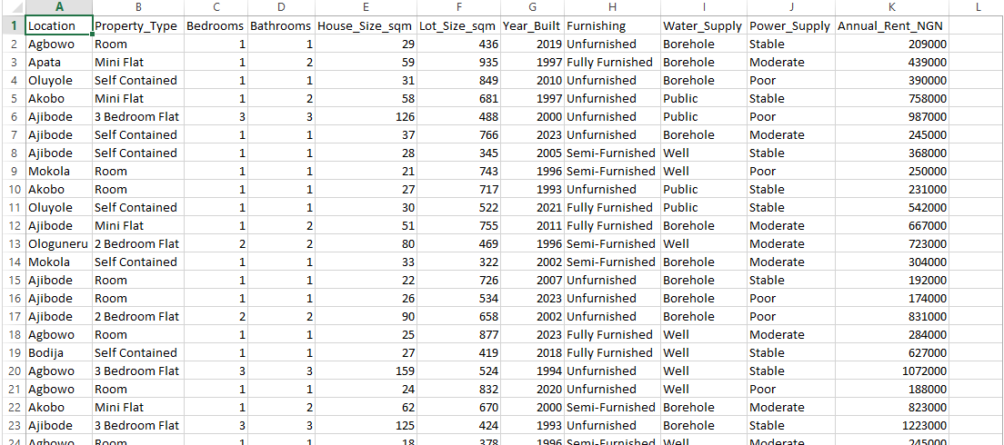
Fig. 4.1 – Dataset Sample (10,000 records × 11 features)
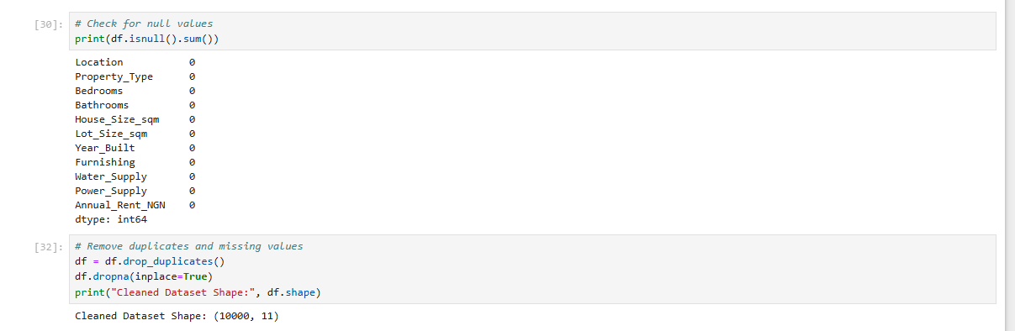
Fig. 4.2 – Data Cleaning: Null Value Check & Duplicate Removal
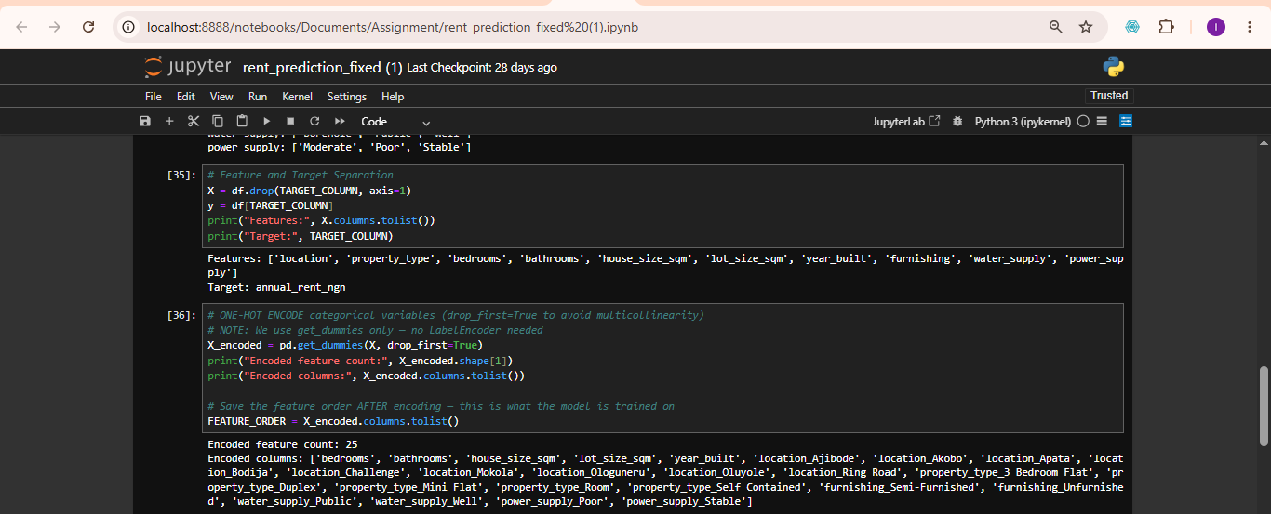
Fig. 4.3 – One-Hot Encoding (25 encoded features)
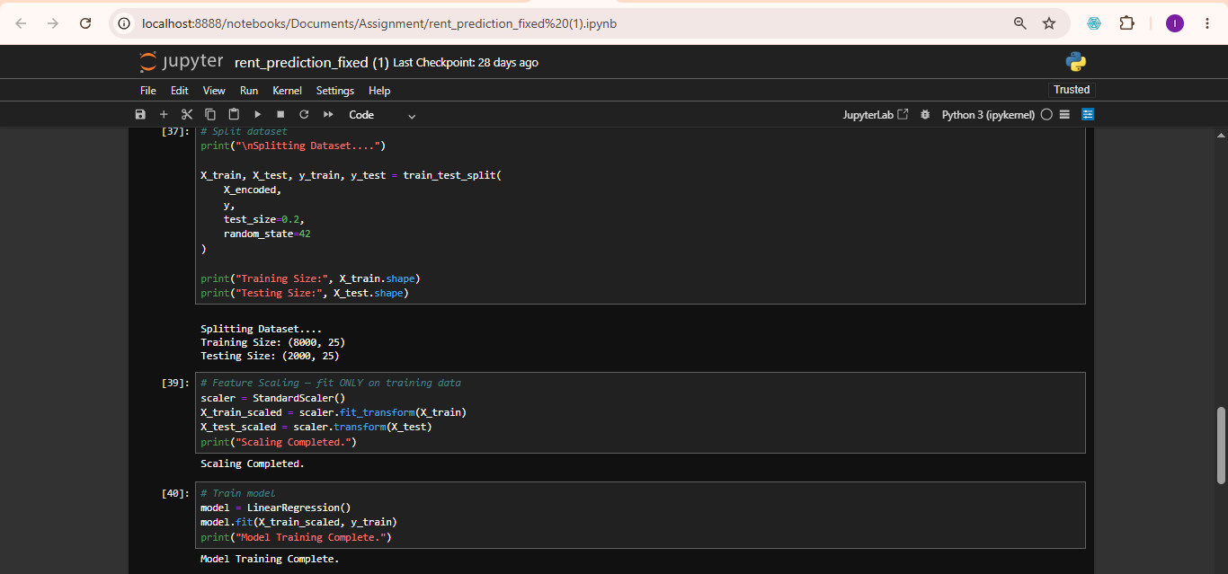
Fig. 4.5 – Model Training (LinearRegression, 8,000 train / 2,000 test)

4.3 Model Evaluation Results
The trained model was evaluated on the 2,000-record test set, producing the following results:
Metric | Value | Interpretation
MAE | ₦71,949.19 | Average prediction error
MSE | ₦13,016,784,372 | Mean squared error
RMSE | ₦114,091.12 | Standard error of prediction
R² Score | 0.9280 (92.8%) | Variance explained by model
K-Fold Cross-Validation Results (5 Folds)
Fold | R² Score
Fold 1 | 0.9280
Fold 2 | 0.9106
Fold 3 | 0.9247
Fold 4 | 0.9222
Fold 5 | 0.9289
Average | 0.9229

These results confirm that the model is accurate, consistent, and generalises well across different subsets of the data. The average cross-validation R² of 92.49% demonstrates minimal overfitting and strong predictive reliability.
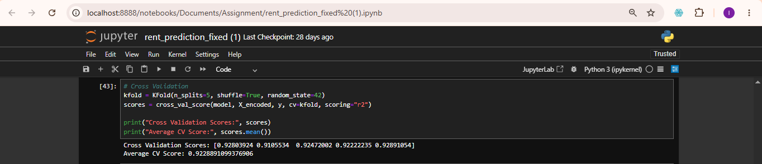
Fig. 4.6 – K-Fold Cross-Validation Scores: Avg = 0.9229
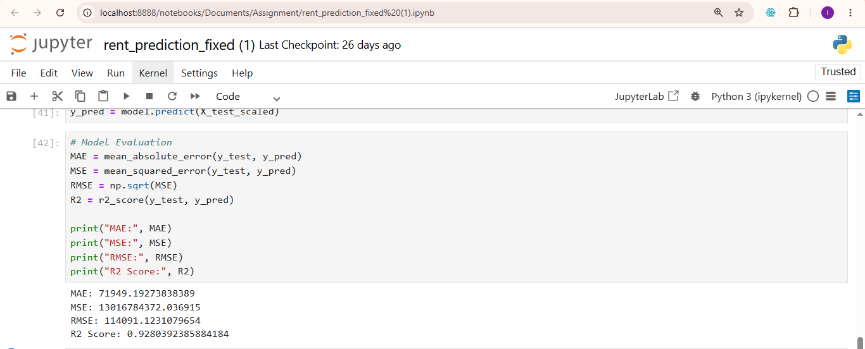
Fig. 4.13 – Model Evaluation Output (MAE, MSE, RMSE, R² Score)

4.4 System Interface Implementation
The system was deployed as a Streamlit web application with the following modules:
- Browse Properties (Home Interface): Displays property cards with images, descriptions, and a 'Predict Rent' button for each listed property. Supports light and dark mode viewing.
- Manual Prediction Interface: Allows users to input custom housing details (location, property type, bedrooms, bathrooms, house size, lot size, furnishing, water supply, PHCN, year built) and receive an estimated annual rent output.
- Prediction Output Interface: Displays the estimated annual rent in Naira along with a property category classification (e.g., Premium, Standard).
- Property Gallery Interface: Carousel display of available properties with images.
- House Comparison Interface: Side-by-side comparison of two selected properties with their predicted rent values.
- Prediction History Interface: Tabular record of all previous predictions including house name, location, predicted rent, and timestamp.
- Market Analytics Interface: Displays model performance metrics (R², RMSE, MAE) and housing market statistics.
- Dark Mode Interface: Toggle for dark/light theme preference, enhancing user experience.
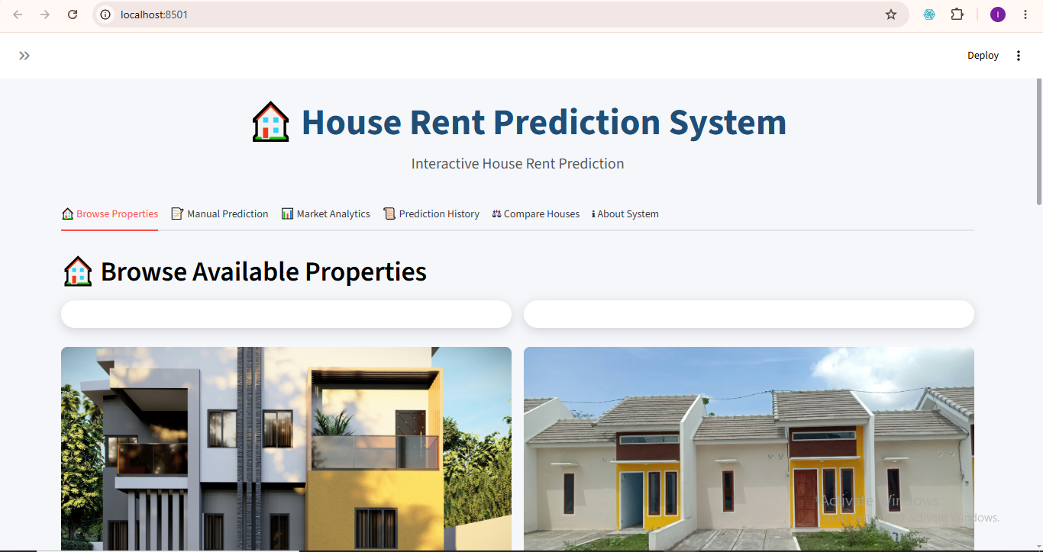
Figure 4.1 – Home Interface: Browse Available Properties
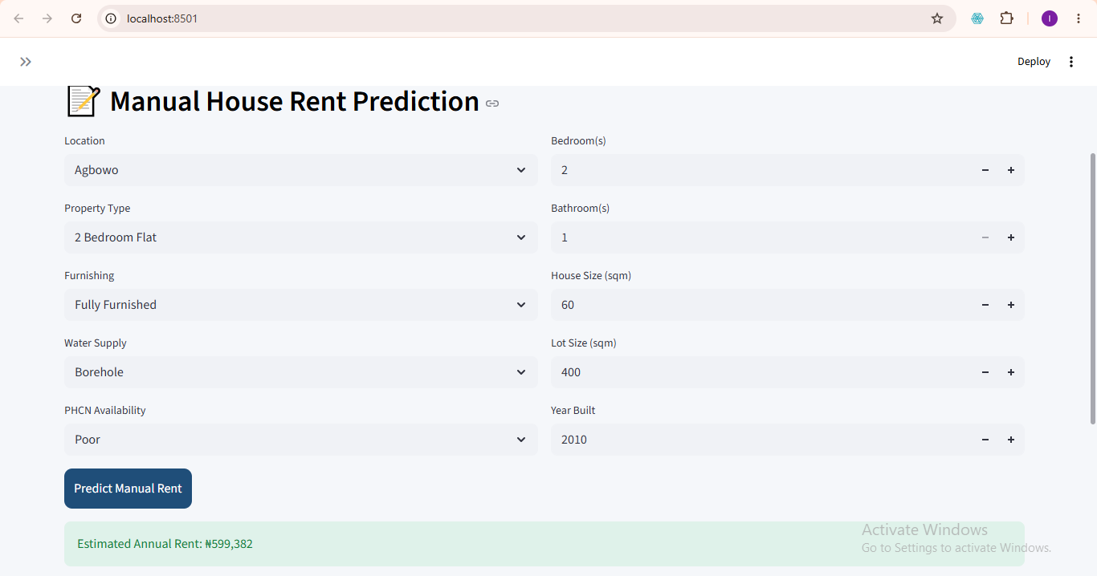
Figure 4.8 – Manual Prediction Output (Estimated Annual Rent: ₦599,382)
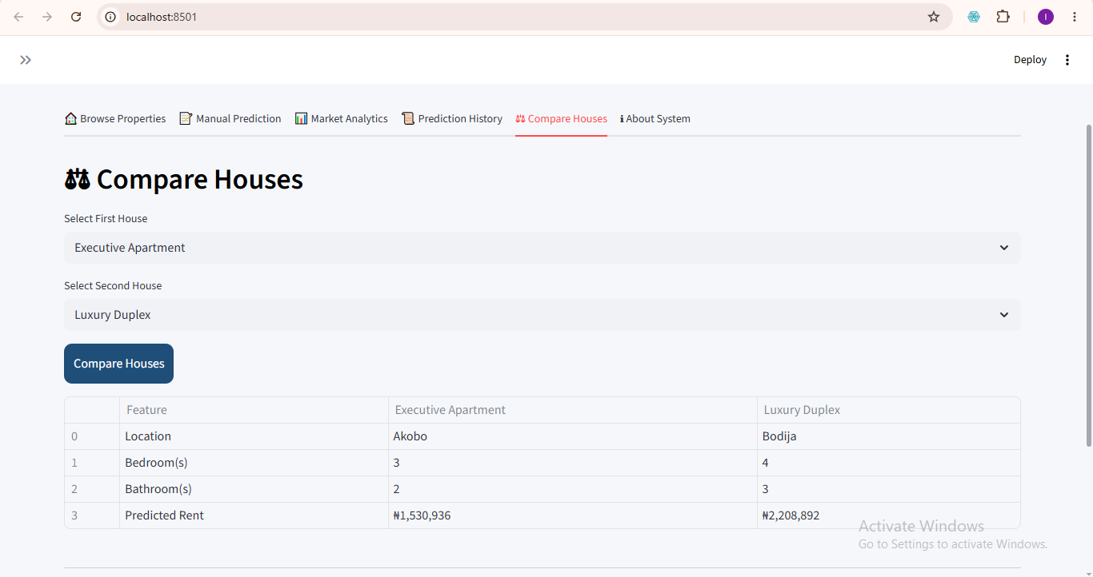
Figure 4.10 – House Comparison Interface
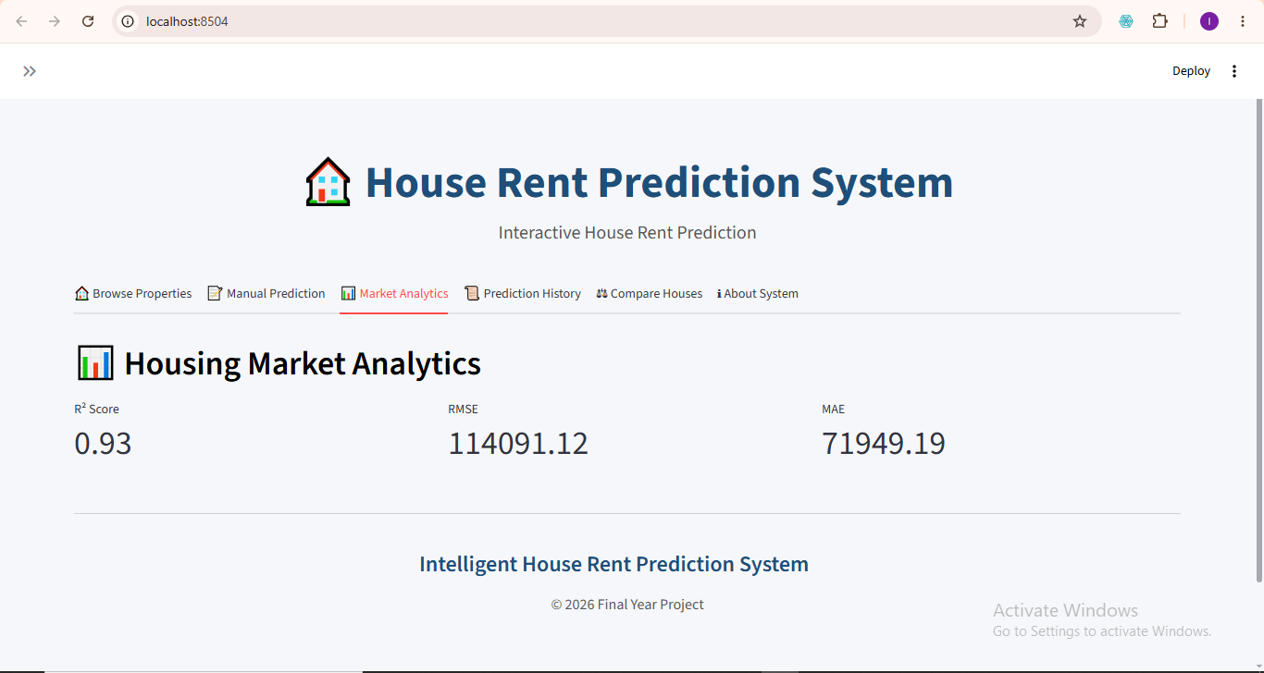
Figure 4.8 – Market Analytics Interface (R²: 0.93 | RMSE: ₦114,091 | MAE: ₦71,949)

4.5 System Testing
Comprehensive testing was conducted across four categories:
Test Type | Description | Result
Functional Testing | All prediction, browsing, and comparison features tested | Pass
Input Validation Testing | Invalid and boundary inputs verified across all fields | Pass
Integration Testing | Streamlit ↔ rent_model.pkl ↔ scaler.pkl ↔ Output tested | Pass
Performance Testing | Prediction speed, interface response, and visual loading assessed | Pass

Chapter Five: Summary, Conclusion and Recommendations

5.1 Summary of the Study
This study developed a House Rent Prediction System using Linear Regression, aimed at addressing the limitations of manual rent estimation in Ibadan, Nigeria. The study followed a systematic approach beginning with data acquisition from house agents and online secondary sources, progressing through rigorous preprocessing (cleaning, encoding, scaling), model development and training, evaluation using multiple metrics and k-fold cross-validation, and final deployment as a Streamlit web application.
The system successfully integrated machine learning prediction with interactive features including property browsing, manual prediction, house comparison, prediction history, market analytics, and dark mode customisation.

5.2 Summary of Findings
- The Linear Regression model was successfully trained and produced an R² score of 0.9280, explaining approximately 92.8% of the variance in annual rent values.
- The 5-fold cross-validation yielded an average R² of 0.9229, confirming model reliability and robustness across different data subsets.
- Effective data preprocessing — including duplicate removal, null value handling, One-Hot Encoding, and StandardScaler — significantly improved data quality and model performance.
- Streamlit deployment improved system usability, enabling non-technical users to perform rent predictions through an intuitive web interface.
- All functional, validation, integration, and performance tests passed successfully.

5.3 Contributions to Knowledge
- Development of a localised house rent prediction model specifically calibrated for Ibadan's housing environment.
- Integration of machine learning prediction with an interactive Streamlit web interface accessible to non-technical users.
- Combination of agent-collected housing data with secondary datasets for improved coverage.
- Implementation of K-Fold Cross-Validation to improve model reliability and minimise overfitting.
- Introduction of visual property exploration, house comparison, and market analytics within a single system.

5.4 Conclusion
The study successfully achieved all three stated objectives: data collection and preprocessing were thoroughly executed; a Linear Regression model was developed and integrated into a functional web application; and the model was rigorously evaluated using MAE, MSE, RMSE, R² Score, and K-Fold Cross-Validation. The developed system demonstrated strong predictive capability with an R² of 92.8% and an average cross-validation score of 92.49%, validating its suitability for real-world housing rent estimation.
The system addresses a practical and pressing problem in Nigeria's rental housing sector by offering an automated, transparent, and intelligent alternative to subjective manual valuation.

5.5 Recommendations
- Explore advanced algorithms (Random Forest, XGBoost, Gradient Boosting, Neural Networks) to compare accuracy against the Linear Regression baseline.
- Expand the dataset to include housing data from other Nigerian cities to improve model generalisation.
- Integrate real-time property platform APIs for automatic dataset updates.
- Incorporate Geographic Information System (GIS) tools for map-based property visualisation.
- Include additional socio-economic variables (road accessibility, security level, proximity to commercial centres) to improve predictive depth.
- Investigate temporal modelling to capture seasonal and time-based rent fluctuations.

References
Balila, A. E., & Shabri, A. B. (2024). Comparative analysis of machine learning algorithms for predicting Dubai property prices. Frontiers in Applied Mathematics and Statistics, 10, 1–15.
Bamiteko, O. D., & Adebiyi, O. O. (2020). Determinant of housing price in Lagos residential market: Role of intermediaries. Journal of Finance and Economics, 8(6), 237–243.
Chuhan, N. (2024). House price prediction based on different models of machine learning. Applied and Computational Engineering, 54(1), 112–120.
Geerts, M., Vanden Broucke, S., & De Weerdt, J. (2023). A survey of methods and input data types for house price prediction. ISPRS International Journal of Geo-Information, 12(5), 1–27.
Odebode, A. A., Oladimeji, D. E., & Ogunbayo, O. T. (2024). An examination of the influence of housing attributes on residential property rental value in South-western Nigeria. International Journal of Real Estate Studies, 18(2).
Olatunji, A. I. (2020). Characterising real estate value as co-determinant of housing choice optimality in Nigeria. Journal of African Real Estate Research, 5(2), 106–132.
Onyejiaka, J. C., Onyima, C. N., & Okafor, J. I. (2025). Examination of factors that lead to rent default on selected residential properties in Awka, Anambra State. International Journal of Real Estate, 1(1), 65–79.
Pai, P. F., & Wang, W. C. (2020). Using machine learning models and actual transaction data for predicting real estate prices. Applied Sciences, 10(17), 5832.
Sharma, H., Harsora, H., & Ogunleye, B. (2024). An optimal house price prediction algorithm: XGBoost. Analytics, 3(1), 30–45.
Solovev, K., & Pröllochs, N. (2021). Integrating floor plans into hedonic models for rent price appraisal. arXiv: 2102.08162.
Tomal, M. (2020). Housing rent and its determinants in Cracow, Poland. Geographia Polonica, 93(3), 317–333.
Yagmur, A., Kayakus, M., & Terzioglu, M. (2022). House price prediction modeling using machine learning techniques: A comparative study. Aestimum, 81, 39–56.
Zulkifley, N. H., Rahman, S. A., Ubaidullah, N. H., & Ibrahim, I. (2020). House price prediction using a machine learning model: A survey of literature. International Journal of Modern Education and Computer Science, 12(6), 34–43.

